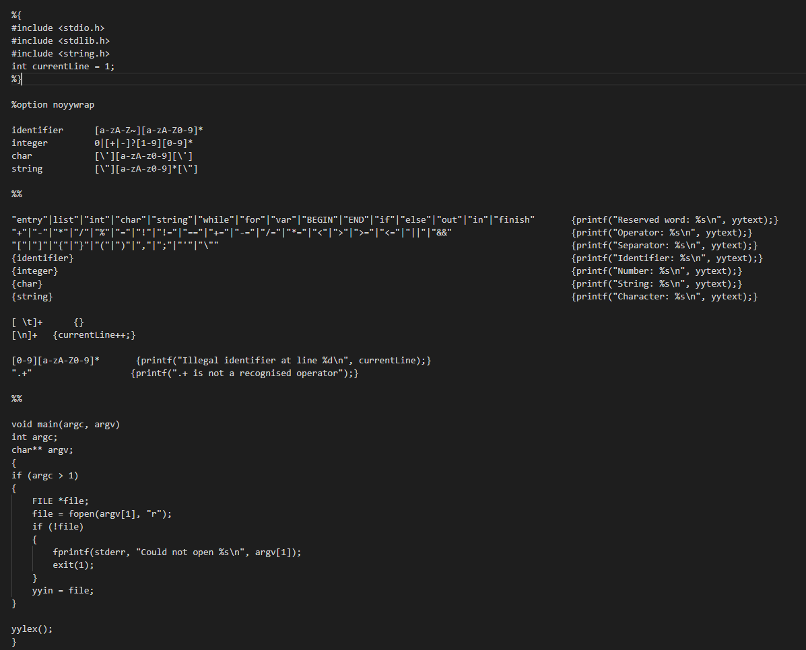

Setup:

Install Lex following this [tutorial](https://www.youtube.com/watch?v=ilwXAchl4uw)

Install GCC from [here](https://sourceforge.net/projects/mingw/)

Run these two commands:



We get an executable file, and then we should run:

